Design Document

B Kendrick, A Syed

Contents

Introduction 2

Environment 2

Hardware 2

Users 2

Operating System 2

Fixed Interfaces 2

DBMS 2

Interfaces to other systems 2

Eclipse 2

BlueJ 3

Methodology 3

System Structure 3

Core 3

Perspective 4

Views 4

Class & Package View 4

Object Bench 4

Inspector 4

Dialogs 4

Utilities 4

System Specifications 5

Programming Language 5

Dependencies 5

SWT Core 5

Eclipse Plugin Development Environment (PDE) 5

Core Concepts & Technologies 5

Reflection 5

SWT 5

Java Model (AST) 6

Core Functionality 6

Activator 6

Instance 6

Template 6

Java Model Helper 7

Views 7

Class/Package Diagram View 7

Object Bench 8

Instance Inspector 8

Dialogs 8

Constructor 8

Method Call 8

Method Return 8

New Class 9

New Package 9

Utilities 9

String Helper 9

Object Utility 9

Template Loader 10

Noteworthy Mechanisms 10

Dynamic SWT Controls 10

Sort Classes (Class Diagram) **(ASH)** 10

Class Re-Loading 10

GUI Designs 10

Perspective 11

Class Diagram View 11

Object Bench 12

Inspector View 12

New Class Dialog 13

New Package Dialog 14

New Instance Dialog (Constructor) 14

Call Method Dialog 15

System Models 15

Activity Diagrams 15

Use Cases 18

Class Diagram 19

Implementation Plan 22

Evaluation Criteria 22

Requirements 22

Testing 22

Black-Box Testing (Usability & Functionality) 22

White-Box Testing (Functionality) 23

Automated Testing (Unit Testing) 23

Regression 23

Acceptance Testing 23

Alpha/Beta Testing 24

A note on Version Numbering 24

Educational Value 24

Following Lessons **(ASH)** 24

Code Testing 24

Client and User Evaluation 24

Comparison 25

Conclusion 25

Glossary 25

References 25

Appendix A: Past Diagrams 25

Appendix B: Document History 27

# Introduction

Outlined in this document are the considerations and specifications for the end product to be created. We will need to consider the requirements outlined in the requirements analysis and factor these into our designs.

# Environment

We need to consider the environment in which the final product will be designed in and a variety of environmental factors that could affect the development of the project.

## Hardware

The system will need to be able to run on the PCs within the University and will need to run on basic computer hardware with varying specifications.

## Users

The software will need to be fully functional and easy to use, early iterations must focus on usability and accessibility.

## Operating System

For the eclipse plugin to work the machine will need to have eclipse installed which can run on both Microsoft Windows and various Linux distributions. Cross-compatibility will ensure that our plugin can be used by a variety of users, however we need to be cautious as the more platforms are supported the more support we may have to provide.

# Fixed Interfaces

## DBMS

The need for any database management systems have not been identified by the client or within the analysis and design phase. However we could utilise one to track classes and changes for recoverability, this is a consideration that should be made but will most likely not be used in the first full iteration of the plugin.

## Interfaces to other systems

### Eclipse

Our plugin will need to be able to interface with the other components of Eclipse. We will need to be able to gather information on active projects. There will also be a need to connect to the Java Model held by Eclipse on user projects.

### BlueJ

It would be a beneficial, but not essential, function of our plugin to be able to integrate with BlueJ, being able to move projects between BlueJ and Eclipse would make transitioning between the IDEs much simpler for new students.

# Methodology

In this section the chosen methodology for the implementation of the product will be outlined and discussed.

Many methodologies and their spin offs were considered and some of these can be read in the research document.

However the iterative prototype method with elements of scrum was chosen for this group project. This was decided from the risk analysis in the risk document and by the research performed in the research document [Reference to those documents?]

This approach is ideal to this group as the member size is only 2 and therefore adopting a full agile methodology seemed unnecessary as these are tailored for small to medium teams which usually consist of at least 5 to 10 members [Get reference here]. The chosen approach allows for the two members of the group to work on both the implementation and documentation side of the product iteratively, each requirement will be completed and tested before the next requirement is addressed. As there is only 2 people this approach is efficient and easy to maintain [Reference here]. The scrum elements that will be present are a weekly meet up with the client to report on progress and discuss on any topics such as requirements validation.

The nature of the product also requires this methodology, as the knowledge of how to implement a plug in for eclipse is unknown. The iterative prototype approach lets us tackle each requirement separately until it is implemented and tested. As each requirement will involve different functionality that will have to be first researched and learned.

Another reason for this approach is that it allows us to receive feedback during implementation from the client or test sessions held with students. As the product is intended for students it would be wise and useful to use feedback from them and the client after each prototype. With the feedback gained and used after each working prototype it ensures a final product which the client truly wanted.

# System Structure

## Core

The core area of the plugin will comprise of the means to activate the plugin and give access to the required runtimes. The core will handle the connection with the Eclipse PDE and allow for easy integration with the IDE. This area will store details such as user preferences and provide access to the Java Model required for the majority of the system. The core will also provide classes to handle instances and any other representation of user data.

## Perspective

The plugin will need a means to control the perspective to be used in the Eclipse IDE. This part of the system will control the layout of the various views that will be accessible to the user. The perspective will be integrated into the Eclipse IDE and be easily selectable to create an easy to use environment for learning programming and providing an easy means for testing methods with user defined classes.

## Views

The views will make up the main components of the system. Here the main functionality of the plugin will be implemented.

### Class & Package View

The class and package view will provide a means to navigate a user project. In this view the packages and classes will be represented graphically with all of the links between them. This view will also enable users to instantiate an instance of their classes to the object bench. This view will also allow for the creation and deletion of both packages and classes.

### Object Bench

The object bench will allow a user to control instances they have created from the class and package viewer. From the object bench an instance will be made active and methods can be called from a context menu. A selected instance will also be viewable in the inspector.

### Inspector

An inspector view will allow users to view the fields and their values within an instance of their own defined classes. This view should also allow users to edit the values of the respective fields.

## Dialogs

Dialogs will be used to handle the majority of user input. These will facilitate the creation of new classes, new packages and the calling of methods. The dialogs will be very easy to use and will allow users to perform the majority of tasks within the plugin. Dialogs will also be used to inform the user of both information output, errors and return values from the methods called.

## Utilities

The utilities part of the system will contain a set of helper classes with the means to perform common operations within the plugin. This will contain methods to help draw GUI elements for constructors and method calls. Utilities will allow us to gain components to assist in allowing user input and parsing classes created by the users. Within the utilities we will also ensure interaction with the file system of a project to enable manipulation of files within a user created project.

# System Specifications

## Programming Language

The plugin will be created using Java, this is because the primary development platform for the Eclipse IDE is Java. A benefit of Java is that it supports reflection, reflection is necessary for inspecting user classes and utilising their methods, constructors and variables whilst operating.

## Dependencies

### SWT Core

The GUI will be built using SWT. SWT provides a high degree of flexibility that allows for custom GUI elements to be built with relative ease, this will minimise complexity in implementing the GUI of the system. However SWT is more complex than other systems such as Swing as such we may encounter issues implementing desired features.

### Eclipse Plugin Development Environment (PDE)

The Eclipse Plugin Development Environment (PDE) provides the required tools to build an Eclipse plugin. This will provide the means to extend any additional functionality of the IDE that we need to and provides us with the tools to create the necessary components of the plugin.

## Core Concepts & Technologies

### Reflection

Reflection will be used to inspect the code created by the user. By using reflection we will be able to obtain all of the defined constructors, variables and methods of a user class and make use of them in our plugin. Through reflection we will be able to create instances of a user class, inspect and edit the variables contained within and call the classes’ methods as required.

Using reflection will enable us to make use of user defined constructs without actually knowing any details about them before-hand. This enables us to allow our plugin the ability to call methods and test areas of user code without prior knowledge of the manner in which user code is defined.

However when using reflection with Java we must be mindful of the manner in which Java loads classes at runtime. If a class is already loaded and the user edits the base class file the class will not be reloaded and as such the user’s edits cannot be used. To this end we will have to devise a means to “reload” the class and reuse it as required.

### SWT

SWT is an open source widget toolkit for Java. We will be utilising SWT to define the majority of the GUI within our plugin. Through SWT we will define custom widgets to represent aspects of the user code as GUI elements as required. SWT provides us with the flexibility to define complex custom GUI elements that will be used to implement the majority of the functionality within the plugin.

### Java Model (AST)

A system to parse the Java Model will need to be devised in order to view the contents of user defined classes. Eclipse contains an Abstract Syntax Tree (AST) that enables us parse user code and utilise the contents within. This will allow us to traverse the model of a user project and make use of all code they have written, by coupling this with reflection we can run methods, change variables and alter the structure of a user project as they require.

## Core Functionality

The core contains the main components used to initialise and create an instance of the plugin.

### Activator

The Activator will act in a similar way to a Java class with a main method; it will initialise the plugin and enable the integration with Eclipse.

### Instance

The instance will provide an interface to an instance to be stored on the object bench.

* **Get/Set Fields -** There will be a means to both get the values of fields and set them as required.
* **Get Method -** A means to get a method ready to be called, this will utilise reflection to gain information on parameters and return types.
* **Call Method –** Call a method contained within the instance.
* **Get Field Class –** Returns a representation of a class used by the requested field.
* **Get Class –** The class type of the instance.

### Template

Templates will represent a template class to be placed into a newly created class.

* **Get /Set Name –** The template will have a name reference for quicker loading.
* **Get Template –** Returns the body of the template to be used in creating a new class.

#### Templates

* **Class –** A basic class with example fields, basic constructor and sample method.
* **Abstract Class –** A sample abstract class with easy over-writable methods.
* **Interface –** A sample interface class with a sample method signature.
* **Applet –** An example applet with initialisation and basic GUI setup.
* **Unit Test –** Simple unit test framework.
* **Enumeration –** A basic enum class, sample will show the days of the week.

## Java Model Helper

The Java Model Helper will provide access to the Abstract Syntax Tree (AST) used by Eclipse to represent a user project, along with all of their packages and classes. This unit will be the most used as it will provide all required information on user packages and the classes contained within said classes.

* **Add Class to Loader –** There will need to be a means to utilise a class loader to ensure that the plugin can load and make use of user classes.
* **Get Project –** Obtain the details of a selected project ready for use throughout the plugin. There should also be a means to keep an active project to be able to determine the information to be used in other methods. Through this we should also be able to determine the state of a project (open/closed) and the type of project it is.
* **Get Packages in Project –** Getting the individual packages and their information for use in drawing the packages in the package view and iteration over packages to find certain classes as required.
* **Get Classes in Package –** A means to get a collection of the classes contained within a certain package. This will be useful to obtain the amount of classes in a package, their names, and any other details required from the model.
* **Get Constructors –** Find the constructors of a given class for use in creating instances. The model helper will need to provide the parameters of a constructor, along with the names and types of said parameters**.**
* **Get Underlying Files –** A means to get the underlying files of a package and the classes within, this could be used for a variety of purposes but primarily for adding to the class loader and handling file creation/deletion.
* **New Class/Package** – The facility to create new classes and packages within specified areas of a project.
* **Get Methods of Class –** The Java Model helper will need to be able to iterate over methods within a class and be able to provide details about the method (name, signature), its parameters (both names and types) and its return type.
* **Get a Loaded Class –** To be used with reflection; this functionality will allow an instance to obtain a copy of its parent class to be able to read and write to fields and call methods as required.

## Views

### Class/Package Diagram View

This view provides the user the means to navigate their packages and classes. The majority of actions and functionality from within this section could be implemented through context menus and simple buttons.

* **Add/Remove Package –** It will be critical that a user can both add new packages and remove them from within this view.
* **Add/Remove Class –** It will be useful for the user to be able to add and remove classes from this view.
* **Edit Class –** An action should be present that allows the user to enter an editor by either accessing an option through a context menu or a double click.
* **Instantiate Class –** From this view the user should be able to instantiate a class utilising the variety of available constructors they have devised.
* **Navigation –** The project open should be navigable in this view, double clicks on packages should show the interior classes of the selected package with an option to return to a level above.
* **Draw Classes –** The classes within a package need to be rendered on screen with full inheritance and dependency links in place accurately.

### Object Bench

The object bench controls the instances created within the class diagram view.

* **Remove Instance –** It will be possible to remove instances from the object bench.
* **Selection & Link to Inspector –** When selecting an instance on the object bench the system will make it active within the inspector view. The bench should also highlight a selected instance.
* **Call Methods –** It will be possible to call the methods of an instance from a context menu attached to each instance.
* **Draw Instances -** The instances should be represented graphically in coloured boxes.

### Instance Inspector

The instance inspector shows information on a selected instance.

* **Get/Set Fields –** From the inspector a user will be able to see the fields of an instance and their current value. It should be possible to edit the values of the fields from within the inspector.
* **Array Editor –** The inspector will also be able to edit arrays of primitive types (and maybe more complex types in the future). In editing arrays the user will be able to change the size and update the values in each individual object within.

## Dialogs

The dialogs will be used to gather user input and relay information to the user. The majority of input dialogs should have cancel and confirm buttons to ensure easy navigation.

### Constructor

The constructor dialog is used to instantiate an object based on a constructor passed as an initial variable.

* **Set Parameters –** The dialog will display the required parameters for the specified constructor and these will have appropriate controls that will define the parameters to be passed to the constructor when instantiating the class.

### Method Call

The method call dialog behaves in a highly similar fashion to the constructor dialog only instead of instantiating a class it calls a method within an instance and triggers a return value.

### Method Return

The method return dialog will display a text representation of an object returned by a method called from the object bench.

### New Class

The new class dialog is called when a user requests a new class.

* **Set Class Name –** The dialog will allow a user to define a name for the new class to be created.
* **Select Template –** The template to be used in the class creation is to be set from this dialog.

### New Package

The new package dialog is called when a user requests a new package.

* **Set Package Name –** The name of a new package will be set from within this dialog.

## Utilities

### String Helper

A string helper will be implemented that will assist in handling a variety of strings and inputs as required.

* **Fix Type –** Object types obtained from the AST often don’t match the actual usable name of the class they represent. A method that will fix these text strings into standard class names will be implemented to ensure correct classes are used when required.
* **Strip Extension –** This will be used to strip an extension from a string. This is useful when dealing with class names from the AST, often classes will have the extension attached (.java) which needs to be removed for loading a class.
* **Qualified Name Creation –** The string helper will be able to build a fully qualified name for a class when given the basic name of a class and a full name of the package that contains it. A fully qualified name is required load a class for use by both the plugin and the users own testing.

### Object Utility

The object utility will contain methods to ease repeated actions within the plugin.

* **Linking to Other Components –** The utility will provide the means for views to interact with one another, each view will register with the utility and then the utility will be able to provide required view objects as required.
* **File Handling –** The controls to delete and edit files will be contained within the utility class to reduce the amount of code required to perform these actions at each point they are required.
* **Get Control –** This will take a given type and return a specific control that will accommodate that type. For example if an integer is passed in to the utility it will return a spinner object.
* **Type Handling –** The utility will be able to determine whether a specific type is known and if it is return the correct class associated with the type given.
* **Get/Set Control Values –** Control values can have data set onto them to control the object to be utilised as required. If the control requires a user defined class a combo box will be built based on objects currently on the object bench.
* **Active Instance Control –** The utility will be able to keep track of the currently selected instance and pass it to the inspector if required.

### Template Loader

The template loader is used to load templates from simple text files and convert the text into a Template class for use in creating new classes on user request.

## Noteworthy Mechanisms

### Dynamic SWT Controls

When working with user variables the system will be able to serve up a SWT widget that can handle the type defined by a user variable. To implement this whenever a user interacts with any areas that requires a variable to be set they will be presented with a relevant control to set the value of the variable/parameter.

A dynamic control will be created that allows for dynamic editing of arrays, a user will be able to re-size arrays and define each variable within an array as required. This will require the creation of a custom SWT composite widget that will provide the means to interact with arrays of any type. However the creation of a custom SWT widget that performs this function will depend on methods implemented to get controls for a variety of types, this will allow us to re-use previous code to set the individual values of objects within an array without the need to hard-code a solution into the array widget.

### Sort Classes (Class Diagram) **(ASH)**

### Class Re-Loading

Java does not support class reloading natively; class reloading is where an existing class is “reloaded” when it is updated with a new body. This means that when a user edits a class the JVM will automatically use the old version of the class instead of loading the new version. This is an awkward limitation within Java and will require a solution to prevent this.

To counter this we propose utilising a new instance of a class loader each time the user edits a class within a workspace. This will have the unfortunate side effect of clearing any objects on the instance bench at the time it will provide us with the means to reload classes at runtime and ensure that the user can utilise new code immediately and without having to restart the IDE.

# GUI Designs

Shown below are the preliminary GUI designs for the plugin.

## Perspective

The perspective is the collection of views offered by the plugin. The Resource view is a default Eclipse view that is utilised by the plugin to select the active project.

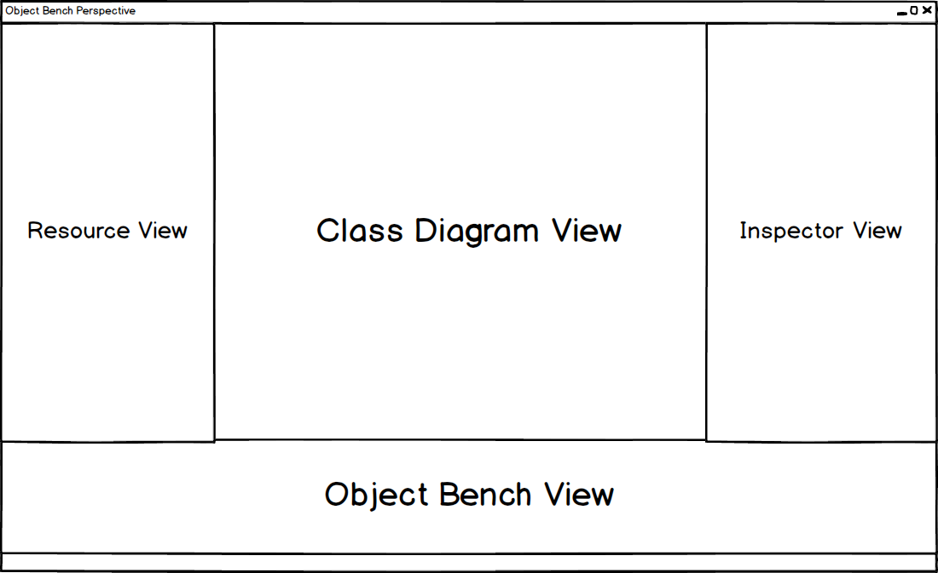

## Class Diagram View

The class diagram view will display the packages and classes within a project. Classes will show inheritance by a solid line and dependency from a staggered line. There will also be buttons for new classes and new packages.

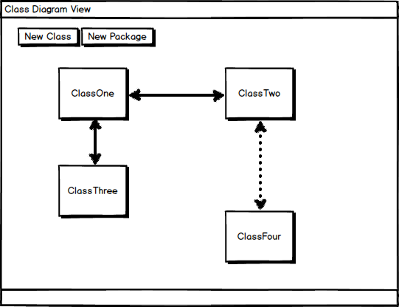

## Object Bench

The object bench will hold instances created from the class diagram view. The instances are represented by coloured buttons. Each button will have a context menu offering the methods from the instance and the means to remove it from the object bench.

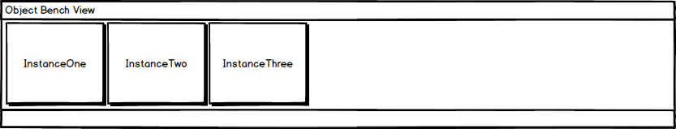

## Inspector View

The inspector view will display a selected instance. The fields will get a required control from the utility class as described above. Arrays will be fully editable with a field offered for size and the fields can be edited as shown by the numbered elements in the design for the inspector.

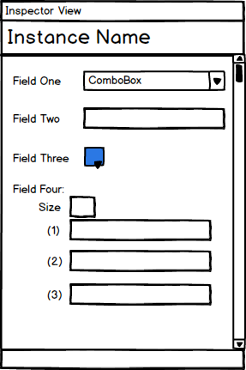

## New Class Dialog

The new class dialog will provide a text box for a class name, radio buttons for the template to be used and buttons for navigation and confirmation.

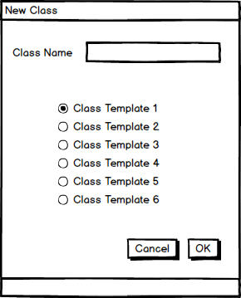

## New Package Dialog

The new package dialog will provide a text box for a package name and buttons for navigation and confirmation.

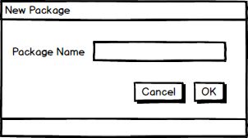

## New Instance Dialog (Constructor)

The new instance dialog will provide controls for the fields required by a constructor and buttons for navigation and confirmation.

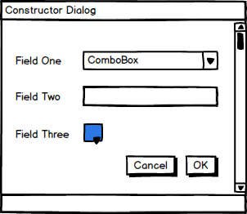

## Call Method Dialog

The call method dialog will provide controls for the fields required by a method and the buttons for navigation and confirmation.

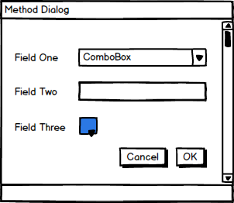

# System Models

In this section UML diagrams will be shown in relation to the requirements set out in the requirements analysis document.

## Activity Diagrams

This diagram is an activity diagram. It shows the process of the user using the system in a step by step fashion; the diagram begins with a start node and ends with an end node. In between these nodes, actions and decisions are outlined.

This version of the activity diagram shows the primary process that the user would take when using the plugin.

After opening the object bench toolkit perspective the user can decide to either create a new java project or select an already existing one. From there the class diagram view is opened, this allows the user to navigate packages and / or classes. The user can either create a package or class or select an already existing class.

From there the user can both open the code editor and add code to that class or instantiate that class. Instantiating the class places the class on the object bench. Selecting this instantiation allows to either inspect it or run a method.

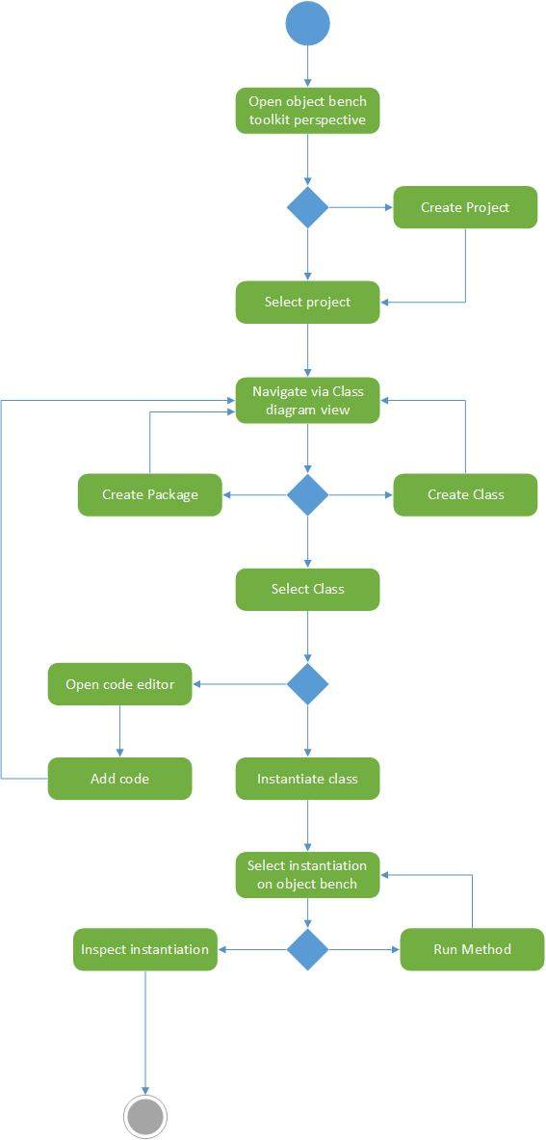

## Use Cases

This diagram is a use case, it shows all the interactions the actor (the user of the plugin in this case) can perform to the system (The Eclipse IDE with the plugin). Here the actor can do the following things:

* Create a new java project
* Select a java project
* Open the perspective of the plugin
* Add a class
* Add a package
* Select a class
* Open the code editor
* Add a method through the code editor
* Instantiate a class
* Selecting the instantiation
* Inspecting the instantiation
* Running a method of the instantiated class
* Running the compiler

## Class Diagram

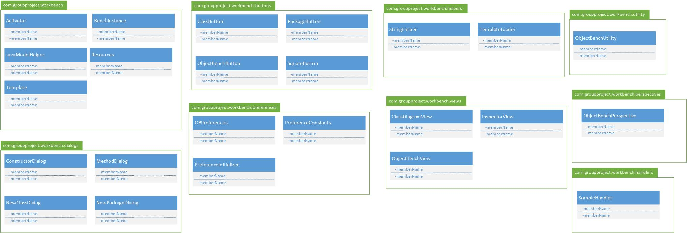



This diagram shows the structure of the packages and classes of the plugin.

The current version is an early draft as packages and classes may get added and removed.

# Implementation Plan

# Evaluation Criteria

A combination of both testing and analysis will enable us to fully evaluate the plugin and assess both its functionality and usefulness. We will also take steps to evaluate the process taken and how well we kept within defined parameters throughout the projects development.

## Requirements

A key area of evaluation for our plugin will be how well it meets the outlined requirements. As a minimum the plugin will need to meet all of the “**MUST**” requirements outlined in our **MOSCOW** analysis[1]. If the plugin meets all of the minimum requirements then the project can be considered a moderate success with room for improvement. If we manage to meet all “**MUST**”, “**SHOULD**” and “**COULD**” requirements then the project will have been a success, at least on a technical level.

Any requirements that are not met will need to be assessed and the reasons for failure outlined and discussed to potentially prevent future re-occurrences of similar issues. Attempts will be made to rectify any potential failure and ensure high standards of completion throughout the creation of the end product.

## Testing

Testing any software solution that can be used to read other users code and utilise it will always be difficult to test thoroughly. The complexity of the project is incredibly high and as such fully testing every scenario is almost impossible, especially with a limited team size. To counter the potential issues we intend to test the plugin by taking a multi-faceted approach combining both black-box and white-box testing to fully explore the operation and effectiveness of the developed plugin.

### Black-Box Testing (Usability & Functionality)

Black-box testing will be performed with a user that has had minimal involvement with the development of the plugin. Black-box testing will be limited due to a lack of resources but will comprise of basic functionality and usability testing. Performing some black-box testing will enable us to find and address issues that will be missed in development due to oversight and potential overfamiliarity with the system. It can be highly difficult to imagine every scenario a user may attempt without allowing a user to use the system under supervision to monitor and assess results as required. There is always a difficulty in designing test cases for black-box tests, this is usually due to the lack of information available to the tester on the inner workings of the system, there can also only be a finite number of tests performed based upon the testers available time. Despite potential limitations it will be a valuable process during testing to ensure a higher standard of quality in the end product. Black-box testing will allow us to gain insight onto the usability of the system and will ensure that the functionality works as intended.

### White-Box Testing (Functionality)

White-box testing will be performed by both active members of the team. In white-box testing we will investigate the inner workings and logic of the system. Performing this testing will be one of the main areas of testing to ensure functionality. Performing tests on code to ensure that we are gaining desired results will be important in validating results produced by the system.

Due to high levels of knowledge in our own system it will be fairly easy to devise test-cases with a variety of data that is known to be safe and along with uncertain and un-tried data to push boundaries of the plugin.

White –box testing will happen throughout development and any bugs logged into the GitHub repository as issues, these issues can be allocated to team members and will provide a log of bugs found during development and provide time-frames for when bugs were fixed or if they are still open. Performing ongoing testing will ensue that we can optimise our system code and add and remove code based upon issues that are found.

We may encounter minor issues whilst testing the software due the high complexity of the plugin and the impossibility of testing every single potential path within the system.

### Automated Testing (Unit Testing)

Automation of testing of the project code will be considered and unit tests may be written to test specific code segments if needed. It is not possible to automate everything in a project but we can attempt to test user input points through unit testing and ensure correct results are returned as required. Unit testing is an area of high risk within the project due to unfamiliarity with the JUnit testing system used by Eclipse; an attempt will be made to utilise unit testing should time permit an opportunity to learn the skills required to create logical and sensible unit tests.

### Regression

Whenever a bug or issue is found and fixed during testing we will need to be careful with regards to regression. Testing for regression will occur to ensure that a bug fix hasn’t caused other issues in functionality or breaching requirements.

Regression testing will be ongoing and tracked through the issue/bug tracker found within the GitHub repository. This form of testing will ensure that any changes made to code to fix one issue or bug does not lead to a variety of new issues.

### Acceptance Testing

To perform acceptance testing the plugin will be presented to second year students and student teaching assistants. A variety of scenarios will be provided for the students to try utilising the software; this will ensure that the plugin meets the outlined requirements.

During this phase of testing we could also distribute a beta version with the means to gather feedback after the sample group have had an opportunity to test the software independently without structure and guided tests, this will enable us to gather data on unexpected scenarios and find bugs that we haven’t planned for.

### Alpha/Beta Testing

#### Alpha

Once we have completed a build of the plugin that includes all of the planned features we will enter into an internal alpha testing phase, this will include the white-box testing described above and will allow us to test all areas of the application before presenting it to our client and potential users. We may demonstrate areas of the software to the client and potential users during this phase to gather feedback on how specific features work and on issues such as program flow and to ensure that the GUI meets requirements.

#### Beta

The beta test will be performed by a sample of the intended audience, here we will ensure that the plugin can be installed and run and can be used to fulfil the intended purposes of the plugin. This stage of testing will allow us to test “real world” scenarios and assess how users will utilise the system. Performing a beta test enables us to ensure a high level of quality in the final product as the majority of bugs found in beta testing should be fixed for a final release to users.

### A note on Version Numbering

For the development of the plugin we will use the following version numbering:

***production.beta.alpha***

This allows for simple and easy tracking of the stage of the project. For example version 0.0.1 would be alpha, 0.1.0 beta and 1.0.0 final production.

## Educational Value

### Following Lessons **(ASH)**

### Code Testing

Whether the plugin assists in testing code will need to be assessed in a holistic manner. If the plugin allows new programmers a simple means to test their code then an argument can be made that the plugin is useful in education based on this single, potentially critical feature.

## Client and User Evaluation

We will meet with both the client and a sample of users and go through each requirement discussing whether it has been met. We will ensure that we gain both feedback and approval from the client and users. This will ensure that our project has met outlined criteria. By gaining feedback from the client and users we will be provided with insight into both successes and failures of the project. This allows us the opportunity to reflect on the project and provide a plan for any future revisions and improvements to the project to be undertaken in the future.

## Comparison

A brief comparison will be conducted between our plugin and other solutions to help better evaluate the usefulness of the plugin. We will look at the features provided by alternatives and compare them to the solution we have devised.

# Conclusion???

# Glossary

# References

<http://www.tutorialspoint.com/software_testing/software_testing_methods.htm>

# Appendix A: Past Diagrams

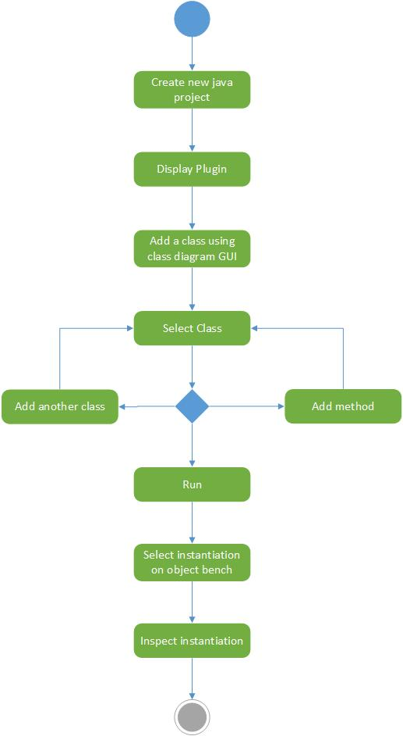

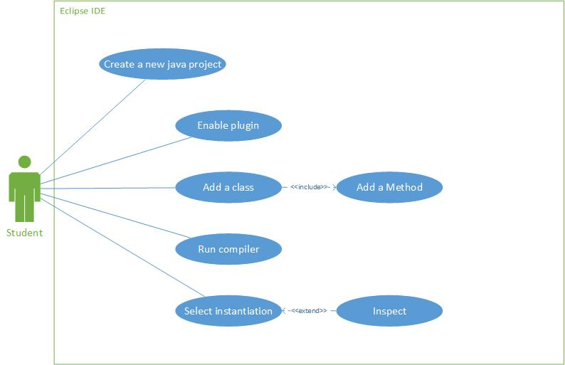

# Appendix B: Document History

* First created 27/12/2014
* Activity and Use case updated 30/01/2015
* Draft Class Diagram added 7/02/2015

1. As found in the Requirements Analysis Document.